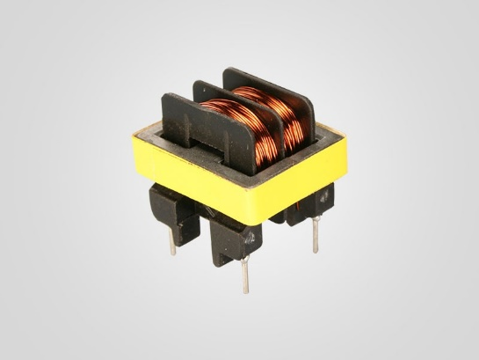
SMPS Transformer (Ferrite Transformer)
1️⃣ Concept – Ye kya hota hai?
SMPS Transformer high-frequency par kaam karne wala special transformer hota hai jo
- Voltage step-down / step-up karta hai
- Primary aur Secondary ke beech isolation deta hai.
Ye normal iron transformer jaisa nahi hota – ye 20kHz – 100kHz par kaam karta hai.
👉 One Line yaad rakho:
SMPS transformer high-voltage ko safe low-voltage me convert karne ka heart hota hai.

